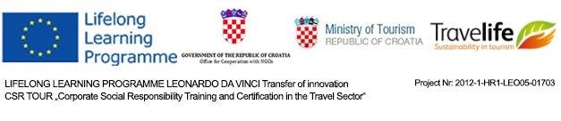
Press Release

FOR IMMIDIATE RELEASE
28th January 2015

The importance of sustainable tourism

Sustainability in tourism is a market demand, not a trend

Zagreb, Croatia - EU funds, joint effort of both business and educational sector with a common goal to promote sustainability in six countries across Europe have proven to be recipe for innovative and sustainable tourism practices.

In a two-year project, eleven educational institutions, seven national tourism associations in partnership with over 200 travel agencies in Croatia, Greece, Poland and Latvia have embraced Travelife system. The project is financed by Life Long Learning Programme – Transfer of Innovation and co-financed and supported by Office for Cooperation with NGOs and Ministry of Tourism of the Government of Croatia.

Travelife is a training, management and certification initiative for tourism companies committed to reach sustainability. On its online platform, it offers educational tools, exams and step-by-step explained certification process.

In mentioned countries, where “„Corporate Social Responsibility Training and Certification in the Travel Sector“ (in short: CSR TOUR) was implemented, association of travel agencies and other professional institutions have assisted the process of education and certification. Result is over 50 travel companies implementing sustainability management system, and over 750 personal certificates of Travelife Sustainability Managers were issued. Both travel agencies and accommodation providers agree that sustainability is necessity demanded by the customers and tour operators and as such is the only professional option. The market dictates minimal negative influence on local communities and cultural and natural heritage.

“Association of Croatian Travel Agencies’ (UHPA) is proud to have members who are willing to run a great businesses that create unforgettable memories for the tourists and jet contribute to sustainable development of local communities and protection of the environment and cultural heritage, “Željko Trezner, director of UHPA, has stated.

From business to schools

The focus has also been put to fast-forwarding innovation from travel industry to educational institutions and their students. Travelife educational tools have been upgraded, translated into four additional languages and provided to trainers for professionals and students. During the trainings, more than 600 pupils and students have gained new knowledge and competences on sustainability in tourism.
Improved interactive modules on internal management will be great help to travel professional and learning tool in educational institutes. | Owners and employees from companies associated with the Silesian Branch of Polish Chamber of Tourism awarded with Travelife personal certificates.

„Polish Chamber of Tourism has committed to CSR TOUR Project because sustainable management in tourism means benefits for the tourist market in terms of environmental protection, cooperation with suppliers and destinations. It also provides a great asset for touroperators and travel agents in terms of competitive advantage and cost savings. Polish Chamber of Tourism is also very much satisfied with cooperation with Polish VET institutes and engagement of students in Travelife training- it means that future staff of tourism companies will be more effective in implementing sustainability in TO&TA management systems. „said Bożena Szawłowska, PIT’s project manager.
In 2012, when the CSR TOUR project was initiated, the concept of sustainable tourism and corporate social responsibility was discussed on a theoretical level within the educational institutions. Doe it was recognized by the travel agencies and hotels they have missed to acknowledge the importance of their role as well as the positive and negative impacts of their business.

Although strong promotion of sustainability and information on undeniable influence of tourism by mass media has been launched, awareness rising in tourism industry was one of the most important goals of the project:

“HATTA, the Hellenic Association of Travel and Tourist Agencies, is happy to have participated in the CSR TOUR Project and considers it an actual success also in Greece. Despite the difficult times for our country, in which we were called to present Travelife to our members, and the various concerns that these difficult times have created for the Greek travel agencies, thanks to this Project we were able to raise awareness among our members regarding the relatively new concept of sustainability in tourism and CSR and the benefits that these could bring to their enterprises, to offer them tools to work towards their certification with Travelife, but also to contribute to the education of young people in these principles, who will integrate them subsequently in their professional life. As is the case with everything new, it needs time to really take root. We are confident, however, that sustainability and CSR, as well as Travelife, have a future in our country, “said Angeliki Rossolatou, HATTA’s project manager.

Asnate Ziemele, the Latvian partners manager: „The Latvian Country Tourism Association "Lauku ceļotājs" and Association of Latvian Travel Agents and Operators highly appreciated participation in the CSR TOUR Project, since it has a number of benefits for sustainable tourism development in Latvia. Both associations are convinced that a sustainable and environmentally friendly tourism is the future of tourism in Latvia and this project provided an opportunity to address this important issue both to Travel agencies who is an important link between tourist and tourism product provider and to VET institutions which prepares the future tourism industry employees. Both the students and the Travel agency professional’s highly-rated CSR training, assessment and award system tool that gives an opportunity to cover comprehensively the sustainability issues and to secure environmental, social and economic sustainability in travel industry.“

Croatian, Greek, Latvian and Polish Tourism Associations will continue to promote sustainability within the tourism industry and help travel agencies, tour operators, hotels and other accommodation facilities to monitor their social and environmental impact, but also to inform guests and business partners on their achievements.

Best practices in one brochure

Behind the CSR TOUR project is the effort, hours of work and many materials that help all companies that seek to improve the quality of services, care of the interests of clients, the progress of the local community as well as environmental protection.

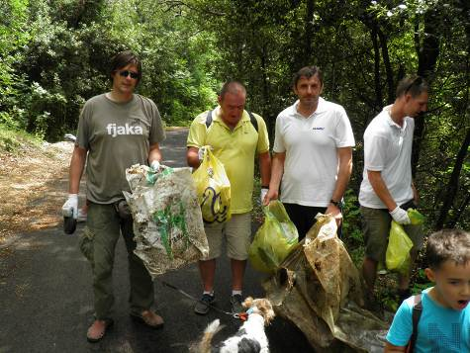 |  | 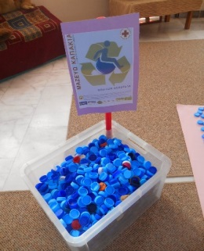 | 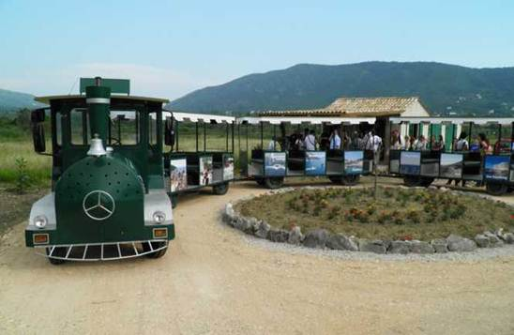
Best practices show that sustainability can be fun, and its success is based on taking small steps on the ‘sustainability road’. There is no ’one size fits all’, every company needs to find its own route

Over 80 examples of good practice from travel agencies from Croatia, Greece, Latvia, Poland, Netherlands and United Kingdom have been gathered. They point out how travel agencies, and all tourism related businesses can use the sustainability as a magnet for tourists and can help local communities, the environment and furthermore educate tourists on sustainable development and the protection of flora and fauna. Examples of good practice are an inspiration to all travel agencies for improvement of their business management and excellent educational material for students. The brochure is available for download on www.travelife.info/csrtour/.

How to get engaged?

For more information, interactive Travelife trainings, videos, tools for planning and reporting please visit www.travelife.info

